SMALL-SHIP EXPEDITION CRUISE
Sable Island: Wild Horses and Outpost Legacy
July 05–11, 2027
From $6,995 to $ 15,725 USD
Aboard the Ocean Nova
Starts: St. John’s, NL, Canada
Ends: St. John’s, NL, Canada

Trip Summary
Out in the open Atlantic, just beyond Nova Scotia’s curve, lies a slender crescent of sand shaped by wind, water, and time. This is Sable Island—a world apart, where wild horses roam free, grey seals gather by the thousands, and rare birds like the Ipswich sparrow make their only home on Earth. Long known to mariners as the Graveyard of the Atlantic, Sable’s story is one of survival, science, and resilience—its dunes and sea winds whispering the tales of centuries past.
Our voyage begins in colourful St. John’s, Newfoundland, before setting sail into open waters rich with seabirds, whales, and dolphins. In collaboration with Parks Canada, we’ll have the rare privilege of exploring this remarkable national park with care and respect. Step ashore by Zodiac (weather permitting) to wander shifting dunes, watch horses crest the ridges, and listen to the music of the sea. Learn from naturalists and historians who bring to life Sable’s human and ecological heritage—from shipwrecks to life-saving stations to today’s conservation efforts.
The journey concludes in Saint-Pierre, France’s last foothold in North America—a cultural gem of cobbled streets, cafés, and island charm. Thoughtfully paced and ethically guided, this expedition offers a once-in-a-lifetime opportunity to experience one of the planet’s most extraordinary and fragile landscapes.

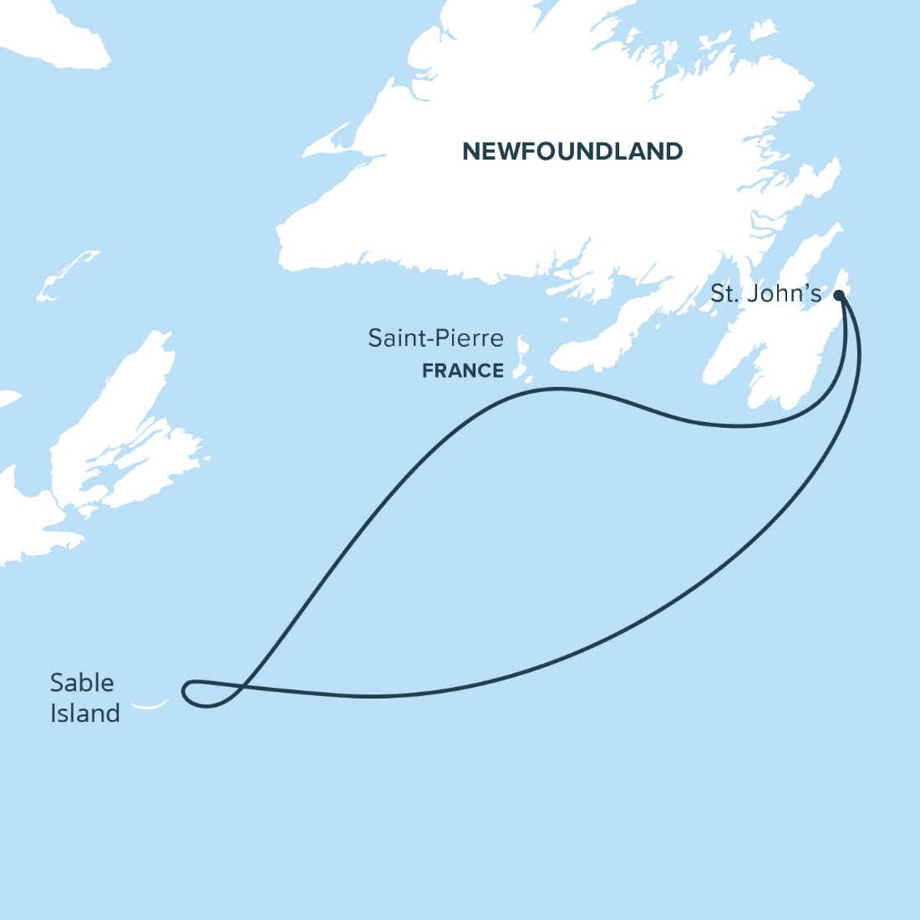

Itinerary

Day 1: St. John’s, NL, Canada
Day 2: At Sea
Day 3–6: Sable Island
Day 7: Saint-Pierre, France
Day 8: St. John’s, NL, Canada

Highlights

A remote island like no other
Out in the North Atlantic, just beyond the curve of mainland Nova Scotia, lies a wind-swept crescent of sand unlike anywhere else on Earth. This is Sable Island—a place of shifting dunes, salt-kissed grasses, and stories whispered through centuries of shipwrecks, survival, and scientific discovery.

Wild horses and rich biodiversity
Today, Sable is best known for its free-roaming horses—one of the world’s last wild equine populations. But these spirited creatures are just one part of the island’s living mosaic. Here, grey seals gather in the tens of thousands, rare birds like the endemic Ipswich sparrow nest amid the marram grass, and hardy plants like sundew and wild iris thrive against all odds. Wind, water, and time are the true architects of this land, sculpting an ever-changing canvas that invites contemplation and curiosity.

A rare opportunity to explore
We’ll have the rare privilege of exploring this remarkable national park at a relaxed pace. Guided by local insight, historical knowledge, and a deep respect for the land and its stories, we’ll walk among dunes, watch the surf for signs of dolphins and seals, and immerse ourselves in the rhythms of a place shaped by nature’s whim.

From shipwrecks to a taste of France
From tales of mariners and meteorologists to the delicate dance of ecological preservation, Sable Island offers perspective and invites reflection. And as our voyage continues onward to the French overseas territory of Saint-Pierre and Miquelon, nestled just off Newfoundland’s southern coast, we’ll enrich our understanding of the region’s diverse cultural and historical richness.
Highlights
- Witness the world’s largest grey seal colony hauled out along windswept beaches
- Encounter Sable’s iconic wild horses, untamed and resilient, moving with quiet power across the dunes
- Wander the shifting sand dunes of this crescent-shaped island—a smile in the sea
- Spot Ipswich sparrows—an endemic subspecies found only here
- Learn about Sable’s human history: shipwrecks, survival, and scientific discovery
- Reflect on the legacy of the island’s life-saving stations and the people who once lived at the edge of the Atlantic

Itinerary
Day 1: St. John’s, NL, Canada
Into the Atlantic from St. John’s, Newfoundland and Labrador
Our journey begins in the vibrant, salt-tinged heart of Newfoundland: St. John’s. With its colourful row houses, steep streets, and lively spirit, this harbour city is not only picturesque—it’s storied. Since 1498, Europeans have fished here, making St. John’s the oldest continuous European settlement in North America. But long before that, this coast was known to Indigenous peoples, the Beothuck, who populated the coast and navigated these waters.
Casting off from St. John’s is a moment to savour. We’ll pass through the legendary Narrows, where Signal Hill towers above—a sentinel to centuries of comings and goings. As Cape Spear, North America’s easternmost point, slips past on starboard, we’ll head into open waters with stirring anticipation.
The adventure is underway.

Day 2: At Sea
Stories, Wildlife, and Ocean Horizons
Our time at sea offers the perfect opportunity to dive into the stories that shape the journey ahead. Today, our on-board presentation series begins in earnest, as members of the expedition team share their knowledge of Sable Island’s extraordinary ecology, geology, and human history.
While the learning continues inside, the outer decks beckon. Keep your binoculars at the ready—this corner of the northwest Atlantic is rich with life. Watch for seabirds, whales, and dolphins from deck. Life aboard balances comfort and discovery—with inviting lounges, great food, a library, and sweeping views of open ocean.

Day 3–6: Sable Island
The Living Sands of Sable
As we approach Sable Island, its long crescent of sand emerges from the Atlantic, an isolated world shaped by wind, water, and time.
Our time there is conducted in close collaboration with Parks Canada, ensuring all visits are respectful of this delicate and protected ecosystem.
Landing by Zodiac (weather permitting), we step onto sand sculpted by wind and tide. Grey seals dot the shoreline like boulders, their grunts and scent carried by the salty breeze. Endemic Ipswich sparrows—the island’s signature songbird—flit among marram grass and beach peas. Arctic and common terns wheel overhead.
Looking to the horizon, wild horses may appear first as ghostly shapes in the mist or as distant silhouettes cresting the dune ridges. You may hear the rhythmic thunder of hooves, and, with patience, you may witness tender moments between mares and foals, or stallions sparring over the attention of a mare.
These animals are not just icons of wildness—they’re testaments to survival, having endured decades of isolation, wind, and shifting sands.
Naturalists will guide our experience with insight into the island’s layered history. We'll hear shipwreck tales, explore shifting landscapes, and learn about Sable’s former life-saving stations—hubs of human endurance in a remote and volatile world. Zodiac outings offer a unique sea-level view of the island’s coastal life, seal colonies, and its ever-changing contours.

Day 7: Saint-Pierre, France
A French Sojourn in Saint-Pierre
Today we arrive in Saint-Pierre—a small but spirited remnant of France nestled off Newfoundland’s southern coast. As the last vestige of France’s once-vast colonial presence in North America, Saint-Pierre offers a cultural experience that feels both familiar and entirely unexpected.
The island’s 6,500 residents are of diverse descent, including French, Basque, Breton, and Norman. Their heritage is evident not only in the language but in the rhythm of daily life—from cafés that spill onto cobbled sidewalks to the melodic lilt of local conversation.
Saint-Pierre’s architecture is as eclectic as its history: narrow alleys, colourful facades, and charming storefronts evoke a sense of old-world charm that’s rare this side of the Atlantic. During our visit, you’ll enjoy a guided tour as well as time to explore at your own pace. Perhaps you’ll sample French wine and cheese, visit a local museum, or simply soak in the island’s unmistakable ambiance.
It’s a day to savour—a little slice of Europe wrapped in salt air and Atlantic mist.

Day 8: St. John’s, NL, Canada
Return to St. John’s
We arrive back in St. John’s in the morning as Sable Island’s imprint lingers: salt on the wind, footprints in the sand, echoes of stories carved by sea and survival. It invites reflection.

Why Travel Here, This Way
Sable Island is both a thrilling destination and a responsibility. Adventure Canada is proud to offer one of the few ways to explore this fragile landscape ethically and respectfully. Our partnership with Parks Canada, commitment to small-group travel, and focus on education ensure your experience leaves a light footprint—and a lasting impact.

