SMALL–SHIP EXPEDITION CRUISE
Newfoundland Circumnavigation
June 13–24, 2027
July 12–23, 2027
From $9,595 to $ 19,440 USD

Aboard the Ocean Nova

Starts: St. John’s, NL, Canada
Ends: St. John’s, NL, Canada

Trip Summary
Journey around Newfoundland, where rugged cliffs, lively outports, and centuries of storytelling shape the rhythm of life along the North Atlantic. From the colourful hillsides of St. John’s to the windswept northern coast, every stop reveals a different side of this remarkable island.
Cross the sea to Saint-Pierre, where French culture thrives amid a stark and beautiful landscape. Receive a heartfelt Mi’kmaw welcome in Miawpukek First Nation, and share in the warmth of Newfoundland hospitality during a community kitchen party in François.
Hike the otherworldly Tablelands of Gros Morne National Park, where the Earth’s mantle lies bare to the sky. Explore the Basque whaling history of Red Bay and the Viking settlement at L’Anse aux Meadows—three UNESCO World Heritage Sites that trace human history across a thousand years.
Aboard and ashore, Adventure Canada’s Taste of Place culinary program celebrates the island’s deep connection to its foodways. Meet the fishers and foragers who bring local traditions to life and sample the flavours that tell Newfoundland’s story.
By the time you return to St. John’s, the sea, the land, and the people will have woven together into something unforgettable—a journey rich in culture, community, and connection.

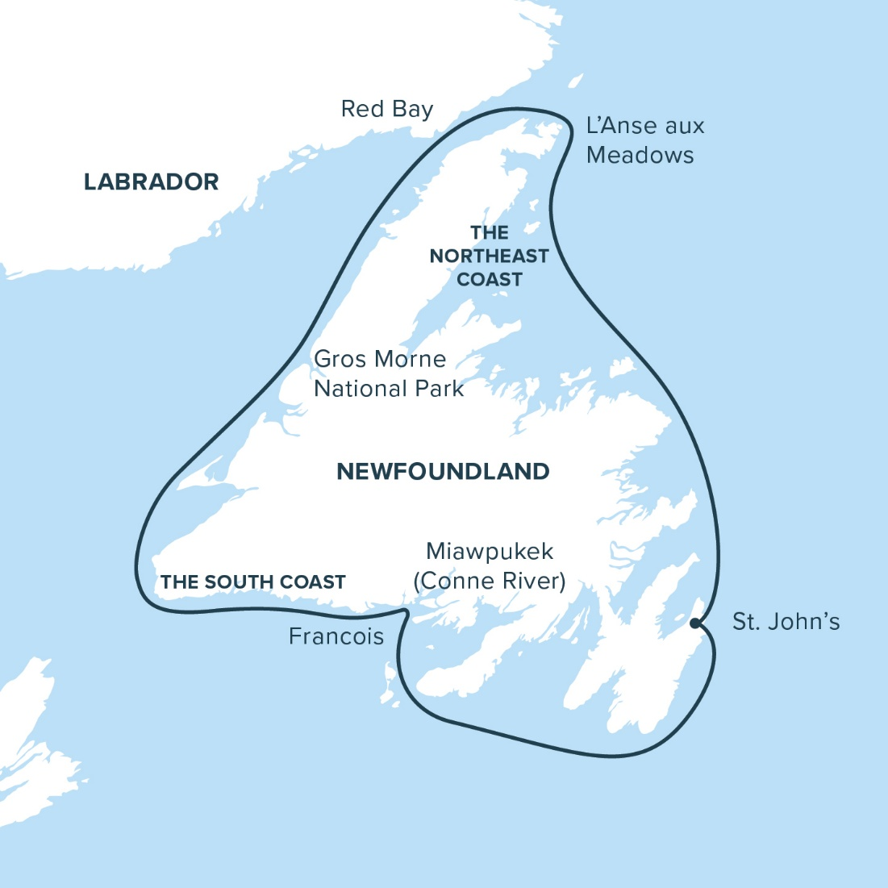

Itinerary
Day 1–2: St. John’s, NL, Canada & Saint-Pierre, France
Day 3: Miawpukek (Conne River), NL, Canada
Day 4: Francois
Day 5: The South Coast
Day 6-7: Gros Morne National Park and Woody Point
Day 8: Red Bay
Day 9: L’Anse aux Meadows
Day 10-11: The Northeast Coast
Day 12: St. John’s, NL, Canada

Highlights
A journey around the rock
There’s a saying in Newfoundland: “You may leave, but you’ll never be the same.”
To travel around this island is to take a deep dive into its stories—told in salt air and tin whistle tunes, sea cliffs and kitchen tables. Each harbour reveals another chapter of resilience, humour, and deep connection to place.
Join local Newfoundlanders from our expedition team as they share the tales, tunes, and traditions of their home. At every stop, you’ll be greeted with the unmistakable warmth, whether in a fishing stage, a community hall, or on the windswept coast. Along the way, receive a heartfelt Mi’kmaw welcome in Miawpukek First Nation and learn how Indigenous traditions continue to shape this land and sea.

Gros Morne National Park: where the Earth turns inside out
In Gros Morne, the world as you know it folds back on itself. Here, the planet’s mantle meets the crust, revealing the striking ochre plateau that is the Tablelands—a geological wonder recognized by UNESCO.
Walk among these raw, ancient stones with our naturalists and learn how life manages to find a foothold in a place where almost nothing grows. The Tablelands are more than scenery; they’re a glimpse into Earth’s deep time.
A little bit of France, just offshore
Off Newfoundland’s southern coast, the tricolour flag flutters in the sea breeze. In Saint-Pierre, the scent of espresso and fresh baguette mingles with salt air, and the rhythm of island life carries a distinctly French cadence. Wander cobblestone streets lined with cafés and boutiques, sample fine pastries, and feel the charm of this enduring outpost of Europe—France’s last foothold in North America, set against the rugged beauty of the North Atlantic.
L’Anse aux Meadows: where the Vikings landed
Step back a thousand years at L’Anse aux Meadows, the only confirmed Norse site on the continent. Here, archaeological discoveries meet living history. Explore reconstructed sod houses, meet interpreters in period dress, and hear stories of the seafarers who crossed an ocean long before Columbus set sail. Join a dialogue about the earliest known chapter of transatlantic exploration.

A Taste of Place: Newfoundland’s living table
Every meal tells a story—of land, sea, and the people who care for both. Adventure Canada’s Taste of Place program brings Newfoundland’s food culture to life through locally inspired dishes and on-board storytelling.
Meet the fishers, foragers, and cooks who keep these traditions alive, and savour the flavours that define this island: freshly-caught cod, bakeapple tarts, moose stew, and more. Each bite supports local, sustainable, and regenerative food systems that honour both people and place.

A circle of stories
To sail the circumference of Newfoundland is to trace a line through deep time and deep culture. From the raw geology of Gros Morne to the living traditions of its people, this is a journey that transforms perspective and stays with you long after the ship’s wake fades into the North Atlantic.
Highlights
- Revel in Newfoundland’s world-famous culture and boundless hospitality
- Experience daily life in remote outports and traditional fishing villages
- Stand where the Vikings once landed at the UNESCO World Heritage Site of L’Anse aux Meadows
- Receive a warm Mi’kmaw welcome in Miawpukek First Nation
- Stroll the colourful streets of Saint-Pierre—France’s last foothold in North America
- Explore three UNESCO World Heritage Sites: Red Bay, L’Anse aux Meadows, and Gros Morne National Park
- Savour local flavours and meet the people behind them through Adventure Canada’s Taste of Place culinary program

Itinerary
Day 1–2: St. John’s, NL, Canada & Saint-Pierre, France
Begin Your Adventure
Your journey begins in St. John’s, the lively and storied capital perched on the edge of North America. Beneath Signal Hill, our vessel slips through the narrow harbour entrance as the city’s colourful row houses glow in the evening light. This is where the island’s rhythm begins—where stories rise and fall with the swell of the sea.
As we sail from St. John’s, the horizon opens toward Saint-Pierre—France’s last foothold in North America. Here, a distinctly French spirit thrives amid a rugged North Atlantic landscape. Wander cobblestone streets lined with patisseries, shops, and seaside cafés. It’s a place where European elegance meets the edge of the sea, and every whaft of salt air carries a hint of history.

Day 3: Miawpukek (Conne River), NL, Canada
Experience Mi'kmaw Culture
In Miawpukek First Nation, the Mi’kmaw people welcome us to a community that has bridged ancient traditions with modern life. Learn about this vibrant nation’s ongoing efforts to preserve language, ceremony, and knowledge of the land and sea. Through stories, song, and shared experience, discover a worldview grounded in connection and respect.

Day 4: Francois
Kick up a Jig at a Kitchen Party
Hidden deep within a steep fjord, the outport of François can be reached only by boat. Colourful homes cling to the hillside, and air carries the quiet cadence of community life. Spend the day exploring waterfalls and lookout trails or simply chat with locals who embody Newfoundland’s legendary hospitality.
As evening falls, the town gathers for a joyful kitchen party—music, dance, laughter, and good company flowing as naturally as the tide. Raise a glass and join in the moment.

Day 5: Southern Coast
Explore a Wild and Beautiful Shoreline
Cruise along one of Newfoundland’s most rugged stretches of coastline, where ancient cliffs rise over quiet coves and hidden bays. We’ll explore by Zodiac and on foot, tracing the contours of this remote landscape. Keep your eyes peeled for seabirds, whales, moose, and caribou—life thrives here in unexpected places.

Day 6–7: Gros Morne National Park and Woody Point
Hike Through Incredible Geology
In Gros Morne National Park, the Earth’s story is written in stone. The ochre slopes of the Tablelands—where the planet’s mantle meets the crust—create a landscape unlike any other. Join our Parks Canada naturalists for guided walks among these surreal formations and learn how Gros Morne earned its UNESCO World Heritage status.
After exploring, enjoy the warm spirit of Woody Point, where artists, writers, and musicians find inspiration in the surrounding mountains and sea.

Day 8: Red Bay
Uncover Basque Whaling History
Step back to the 1500s at Red Bay, once a bustling Basque whaling station and now a UNESCO World Heritage Site. Visit the excellent interpretation centre to see recovered artifacts—including tools and personal items from the ship San Juan, lost here in 1565. Then, cross to Saddle Island to explore the remnants of a whaling community that helped shape the earliest chapters of transatlantic industry.

Day 9: L’Anse aux Meadows
Walk in the Footsteps of the Norse
At the northern tip of Newfoundland lies L’Anse aux Meadows, the only authenticated Norse site in North America. Step inside reconstructed sod dwellings and imagine the Norse explorers who crossed the Atlantic more than a millennium ago. Here, archaeology meets legend—linking Norse sagas to the rugged beauty of Newfoundland’s northern coast.

Day 10-11: Northeast Coast
Discover Outports and Ocean Heritage
As we sail along the northeast coast, each harbour reveals a new perspective on island life. Visit small fishing communities where weathered boats rest in calm coves and friendly faces greet you at the wharf. Capture the texture of coastal living—salt-streaked sheds, drying nets, and stories told over mugs of tea. This is the living heartbeat of Newfoundland.

Day 12: St. John’s, NL, Canada
Wave a Fond Farewell
We return through The Narrows, back into the embrace of St. John’s harbour. The journey’s end is a circle closed—but the impressions linger: the warmth of newfound friends, the taste of sea air, the sound of a tin whistle drifting over the waves.
Our expedition team will assist with luggage and onward travel—but Newfoundland, as locals say, will stay with you long after you’ve gone.

