SMALL–SHIP EXPEDITION CRUISE
Gulf of St. Lawrence: Wild & Storied
June 24 to July 5, 2027
From $8,595 to $17,995 USD

Aboard the Ocean Nova

Starts: St. John’s, NL
Ends: St. John’s, NL

Trip Summary
Sail into the heart of the Gulf of St. Lawrence, where land, sea, and story converge in one of Canada’s most diverse and captivating regions. Beginning in the vibrant harbour of St. John’s, trace coastlines shaped by wind, tide, and time—from the remote fjords of Newfoundland’s south shore to the wind-carved islands of Québec’s lower north shore.
Step into Nitassinan, the Innu homeland on Québec’s North Shore, where language and tradition still flow with the tides. Wander among the limestone giants of Mingan Archipelago National Park Reserve and explore Anticosti Island, a UNESCO World Heritage Site where waterfalls plunge through fossil-rich canyons and deer roam wild forests. Sail beneath the monumental arch of Percé Rock and witness the skies alive with gannets and kittiwakes over Bonaventure Island’s soaring cliffs.
In the Îles-de-la-Madeleine, experience Acadian warmth through music, food, and storytelling. Cross the sea to France’s doorstep in Saint-Pierre-et-Miquelon, where European charm meets Atlantic resilience. Along the way, whales breach, seabirds wheel, and every horizon reveals a new chapter in the region’s living story.
This voyage through the St. Lawrence is both a journey through place and a passage through time—an invitation to discover the wild beauty, rich cultures, and deep histories that have shaped these storied shores.

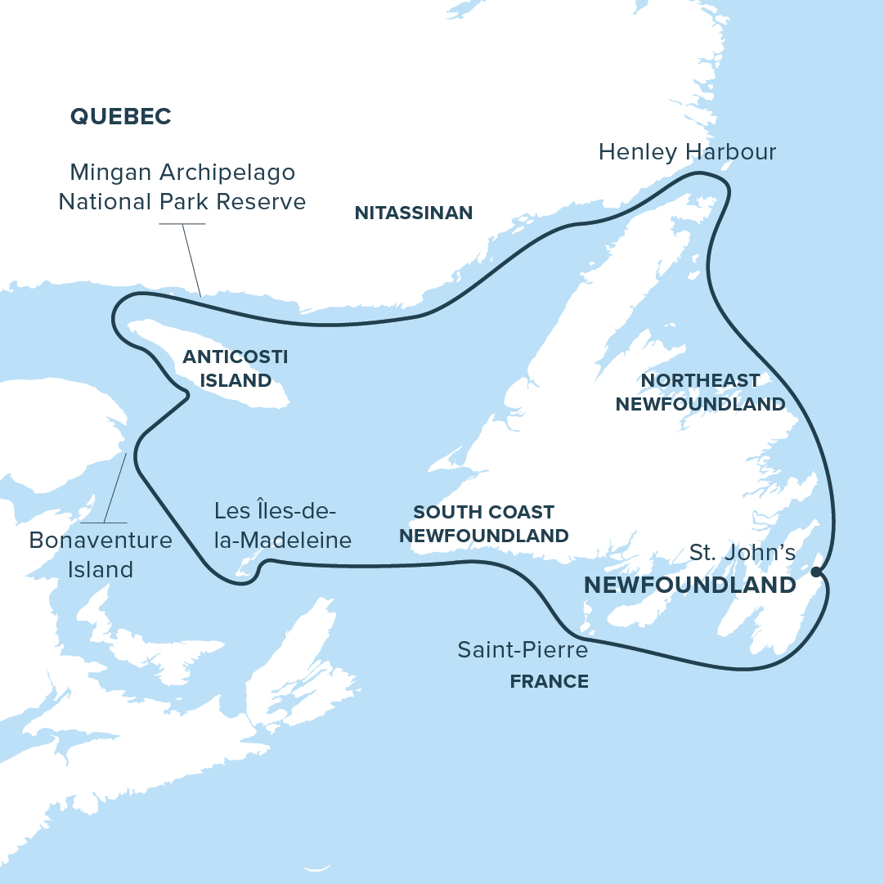

Itinerary
Day 1: St. John’s, NL, Canada
Day 2: Northeast Coast
Day 3: Henley Harbour & Castle Island
Day 4-5: Nitassinan, QC
Day 6: Mingan Archipelago National Park Reserve
Day 7: Anticosti UNESCO World Heritage Site
Day 8: Parc national de l'Île-Bonaventure-et-du-Rocher-Percé
Day 9: Îles-de-la-Madeleine
Day 10: South Coast, NL
Day 11: Saint-Pierre-et-Miquelon, France
Day 12: St. John’s, NL, Canada

Highlights
Bonaventure Island and Percé Rock
At the eastern tip of the Gaspé Peninsula, Percé Rock signals your arrival into the heart of the Gulf. Nearby, Bonaventure Island is alive with wings and wind—where rock and life converge in one of the world’s great coastal spectacles.

Anticosti Island, UNESCO wilderness
On Anticosti, the fossil-rich rocks remember. Waterfalls plunge into ancient canyons, deer roam forested trails, and every cliff tells a chapter in Earth’s deep past. This is Québec’s wild island—timeless, untamed, and full of story.

Îles-de-la-Madeleine (Magdalen Islands)
These wind-carved islands pulse with Acadian culture. Hear the dialects, taste the sea, and meet people whose art and resilience are shaped by salt air and sweeping light.

Mingan Archipelago National Park Reserve
Explore Canada’s largest concentration of erosion-carved limestone monoliths. This coastal landscape invites slow discovery, revealing forms shaped by wind, sea, and time.

Spot whales and seabirds in the Gulf
Where warm and cold currents meet, life surges creating one of the richest areas in the world for marine mammals. The Gulf of Saint Lawrence is an aquatic crossroads—home to migrating whales, seabirds, and moments of awe you’ll never forget.

In the heart of Nitassinan
Explore the Innu homeland of Nitassinan (on Québec’s lower north shore), where traditions stretch back millennia and the rhythms of land and language continue to shape coastal life. This is a place to listen deeply—to both the people and the land they call home.

Highlights
- Admire Percé Rock from the sea and watch thousands of seabirds on Bonaventure Island’s soaring cliffs.
- Experience waterfalls, fossils, and wild beauty on UNESCO-designated Anticosti Island.
- Immerse yourself in Acadian culture on the wind-shaped Îles-de-la-Madeleine.
- Wander among the limestone monoliths of Mingan Archipelago National Park Reserve.
- Explore the Innu homeland of Nitassinan, where land, language, and tradition remain deeply connected.
- Marvel at whales and seabirds thriving where ocean currents meet in the Gulf of Saint Lawrence.
- Discover colourful harbours and timeworn outports along Newfoundland’s storied coast.
- Stroll cobbled streets and savour a taste of France on the island of Saint-Pierre.

Itinerary
Day 1: St. John's, NL, Canada
Harbour City at the Edge of the Atlantic
Your journey begins in St. John’s, a vibrant North Atlantic city where history and commerce meet. Set in a vast, amphitheatre-like harbour, the port hums with activity—freighters, cruise ships, offshore vessels, and fishing boats sharing the water below steep hills and colour-splashed neighbourhoods.
As we sail out through the passage known as the Narrows, Signal Hill keeps watch above, and the bright façades of the Battery seem to cling to the cliffs. If we’re lucky, a whale or two may mark the start of our voyage into the open Atlantic.
Day 2: Northeast Coast
Life Beside the Iceberg Alley
Trace the rugged shoreline shaped by the cold, nutrient-rich Labrador Current, aka Iceberg Alley—a marine lifeline that sustains seabirds, whales, and the communities who have long made their lives here. Along this coast, weathered wharves, brightly painted boats, and enduring, hand-built homes speak to generations of resourcefulness.
Whether from ship or shore, you'll witness a landscape where ocean rhythms govern daily life and where craggy headlands, sweeping skies, and working harbours offer endless fascination for the curious and the camera-ready.
Day 3: Henley Harbour & Castle Island
Stone Altars and Stories in the Wind
Wander through Henley Harbour, a once-thriving fishing village now gently surrendering to time. Weathered buildings lean away from the wind, and history lingers in the quiet.
Above the harbour, a striking formation of basalt columns known as the Devil’s Table rises like a stone altar. Nearby, Castle Island, with similar basalt columns, rises like a natural fortress, its sheer cliffs formed over half a billion years ago.
Days 4–5: Nitassinan, QC
Voices of the Innu Shoreline
Visit Nitassinan, the ancestral homeland of the Innu Nation, along Québec’s lower north shore. In communities such as Unamen Shipu or Natashquan, local hosts welcome us into a living culture shaped by thousands of years of deep connection to land and sea.
Over two days, you’ll hear the cadence of Innu‑aimun, listen to stories passed down through generations, and engage in moments of respectful exchange—whether through food, craft, language, or laughter.
Day 6: Mingan Archipelago National Park Reserve
Limestone Giants and Island Wilds
Sail into a dreamscape of stone and sea. Along this Gulf coast, wind and water have sculpted limestone into monoliths—towering figures that rise from the Gulf like natural cathedrals. This is Canada’s largest concentration of erosion-carved limestone monoliths—but it’s also a place where geology, ecology, and imagination meet.
Among a maze of islands and islets, puffins, razorbills, and terns nest on grassy ledges. Spring awakens the meadows with wildflowers, while seals stretch out on sun-warmed rocks. Every curve of the coastline invites wonder.
Day 7: Anticosti, UNESCO World Heritage Site
Fossils, Falls, and a Chocolate Baron's Dream
Welcome to Anticosti—Québec’s wild island in the Gulf and a newly designated UNESCO World Heritage Site. Here, fossil-rich cliffs and deep canyons tell a story 450 million years in the making. White-tailed deer wander through boreal forest, and Arctic-alpine plants cling to windswept rock.
You’ll hike to Vauréal Falls, where spring melt sends water crashing into a sheer-walled canyon, and explore the community of Port-Menier—founded by French chocolate magnate Henri Menier and still home to islanders proud to call this place their own. In spring, Anticosti is untamed and alive: a landscape shaped by time, rich with life, and layered with human stories.
Day 8: Parc national de l’Île-Bonaventure-et-du-Rocher-Percé
Gateway Rocks and Gannet Skies
Sail into one of Québec’s most iconic coastal scenes. Rocher Percé—its massive stone arch rising from the sea—greets us like a gateway to the wild. Get rare views of this geological wonder from the sea. Nearby, Bonaventure Island comes alive each spring with the calls and wingbeats of over 100,000 northern gannets, one of the largest and most accessible colonies in the world.
Watch for kittiwakes, murres, and other seabirds beating their way to or from the feeding grounds or nesting along the ledges. This is a place where geology, biodiversity, and Acadian spirit meet—endless inspiration for photographers and nature lovers.
Day 9: Îles-de-la-Madeleine
Acadian Spirit and Island Bounty
Where red sandstone cliffs meet wide beaches and salt-tinged air, the Îles-de-la-Madeleine reveal a bold expression of Acadian identity. Though part of Québec, these islands are geographically closer to the Maritimes—and feel entirely their own.
Spend the day exploring vibrant fishing villages, lively studios, and cafés where Acadian voices prevail. Meet some of the 12,000 residents who call this windswept archipelago home and taste the island’s bounty: fresh-caught lobster, local cheeses, smoked delicacies, and small-batch wines and beers.
The Magdalen Islands are rich in culture, cuisine, and character—and always ready with a warm welcome.
Day 10: South Coast, NL
Wild Shores and Deep Fjords
Along Newfoundland’s rugged south coast, the landscape invites exploration at every turn. We’ll navigate a coastline carved with hidden bays, narrow fjords, and steep headlands—each offering a new window into the island’s geological story.
Depending on conditions, we’ll land by Zodiac to hike, beachcomb, or simply stand and take it all in. Wildflowers may brighten the barrens and wildlife appears when least expected. This is the kind of day that rewards flexibility and curiosity—where the journey is shaped by wind, sea, and a spirit of discovery.
Day 11: Saint-Pierre-et-Miquelon, France
Europe by the Rock
Just off Newfoundland’s coast, step ashore into a world of cobblestone streets, brightly painted houses, and unmistakably French charm. Saint-Pierre is a living remnant of France in North America—complete with gendarmes, boulangeries, cafés, and markets that hum with island life.
Explore the town’s unique blend of European elegance and Atlantic resilience. Taste fresh pastries, sip local wine, browse French goods, and hear the stories that shaped this overseas community—from maritime traditions to rum-running intrigue. It’s a small island with a big cultural presence—familiar, and yet delightfully foreign.
Day 12: St. John’s, NL, Canada
Homeward Through the Narrows
This morning, we sail back through the Narrows into the wide embrace of St. John’s harbour. The colourful houses of the Battery welcome us home, and Signal Hill stands watch, just as it did at our departure.
As we disembark, we’ll say farewell to shipmates and expedition team members who have shared stories, sightings, and unforgettable moments along the way. The journey ends—but the experience, and the connections made, will travel with you long after the lines are tied.

