SMALL–SHIP EXPEDITION CRUISE
Ellesmere Island and North Greenland: Journey to the Top of the World
August 19 to 31, 2027
From: $11,995 to $22,875 USD

Aboard the Ocean Nova

Starts: Ottawa, ON, Canada
Ends: Ottawa, ON, Canada

Charter Flights:
Northbound Charter Flight: $1,250 USD
Ottawa, ON, Canada to Resolute, NU, Canada. Early-morning departure.
Southbound Charter Flight: $1,250 USD
Resolute, NU, Canada to Ottawa, ON, Canada. Evening arrival.

Trip Summary
At the edge of the map, where sea ice drifts beneath luminous skies, lies a place where natural beauty and human history converge. On Ellesmere Island and North Greenland: Journey to the Top of the World, you’ll travel farther north than on any other Adventure Canada voyage.
Here, at the southern entry to the polar sea, Kane Basin, Smith Sound, and the Nares Strait unfold in a world of drifting ice and layered histories. Beginning in Qausuittuq (Resolute), sail through Tallurutiup Imanga, a thriving Arctic sanctuary where whales and seabirds flourish. Cross into Greenland to visit the Inughuit community of Qaanaaq, navigate the powerful channels between Greenland and Ellesmere Island, and step ashore on Tartupaluk (Hans Island)—a place of shared care and enduring Inuit connection.

Along the way, walk the sweeping tundra of Devon Island, reflect at Beechey Island, and experience the stillness of landscapes few have ever witnessed. For the curious traveller, this is a rare opportunity to experience the High Arctic where geography, culture, and story meet, revealing the heart of the North—profound, humbling, and alive.

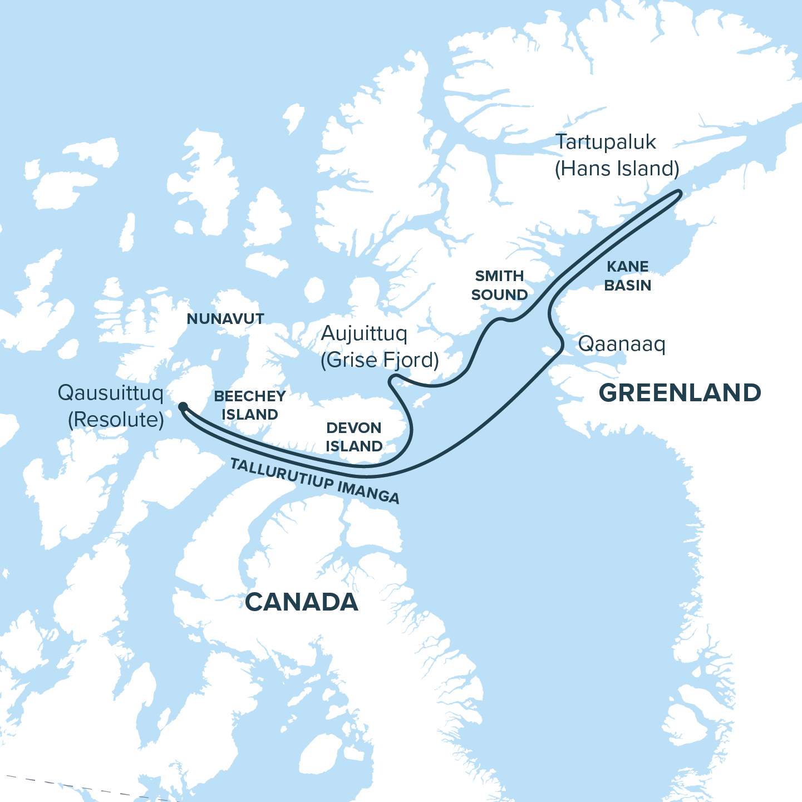

Itinerary
Day 1: Qausuittuq (Resolute), NU, Canada
Day 2-3: Tallurutiup Imanga (Lancaster Sound)
Day 4: Qaanaaq, Greenland
Day 5-6: Kane Basin
Day 7: Tartupaluk (Hans Island)
Day 8-9: Smith Sound
Day 10: Aujuittuq (Grise Fjord), NU, Canada
Day 11: Devon Island
Day 12: Beechy Island
Day 13: Qausuittuq (Resolute), NU, Canada

Highlights
Travel through Inuit Nunangat alongside Inuit
Journey through the ice, water, and lands of Inuit in the company of northern hosts who share their stories, art, and traditions. Experience the living culture of the Arctic as you visit vibrant communities, sample country food, and gain a deeper understanding of the enduring connection between Inuit and the nuna (land).

Sail to the southern entry of the polar sea
Venture farther north than on any other Adventure Canada voyage, navigating Kane Basin, Smith Sound, and the Nares Strait. Here, drifting ice, luminous skies, and immense landscapes forge moments that define the spirit of true exploration.
Experience living culture across borders
Across Nunavut and northern Greenland, Inuit culture flows freely—woven through family ties, traditional knowledge, and the rhythms of the land and sea—unconfined by the borders of nations.

Explore one of Canada's richest marine sanctuaries
In Tallurutiup Imanga, whales and seabirds thrive amid striking cliffs and sweeping valleys. Step ashore on Devon Island, the world’s largest uninhabited island, where glaciers meet the sea and traces of Inuit life whisper through the stone and tundra.
Stand on Tartupaluk (Hans Island)
Few travellers will ever stand upon this small, windswept island in the Nares Strait. Once the focus of a symbolic sovereignty dispute, Tartupaluk now embodies shared care for the North—and honours the enduring Inuit connections that unite these northern shores.
Connect with human stories past and present
From Qaanaaq and Aujuittuq, where vibrant northern communities thrive, to Beechey Island, where Inuit knowledge reshaped the Franklin story, this journey reveals the living and layered histories that define the High Arctic.
Highlights
Journey through Inuit Nunangat—the ice, water, and lands of Inuit—and experience the deep privilege of travelling where culture and environment are one.
Sail to the southern entry of the polar sea and venture farther north than on any other Adventure Canada voyage, navigating through Kane Basin, Smith Sound, and the Nares Strait.
Experience living culture across borders as you discover enduring Inuit connections between Nunavut and northern Greenland—where family ties, shared traditions, and deep knowledge of the land unite communities across the Arctic.
Explore a thriving Arctic sanctuary in Tallurutiup Imanga, where marine mammals and seabirds flourish alongside the glacier-carved cliffs and sweeping northern skies of Devon Island.
Stand on Tartupaluk (Hans Island), a remote island that now embodies shared care for the North and honours the enduring movement of Inuit across these waters.
Connect with Northern histories as you encounter vibrant communities and storied landscapes, from Qaanaaq and Aujuittuq to Beechey Island, where the legacies of Inuit life and Arctic exploration converge.

Itinerary
In the High Arctic, weather, ice, and community priorities guide every journey. Flexibility leads to the best discoveries.

Day 1: Qausuittuq (Resolute), NU, Canada
The North Beckons
Beneath the lingering glow of the Arctic summer sun, Qausuittuq, “the place with no dawn,” welcomes you to the High Arctic. Set amid gravel flats and rolling moraine, this community carries stories of adaptation and renewal, from relocation in 1953 to its role today as a gateway for Arctic research and travel. Take time to orient yourself to the land and its stories before embarking aboard the Ocean Nova. The North awaits.

Days 2–3: Tallurutiup Imanga (Lancaster Sound)
Whales, Ice, and Vast Horizons
Enter Tallurutiup Imanga, a thriving marine sanctuary where whales, walrus, seals, and seabirds gather among towering cliffs, deep fjords, and endless horizons. Step ashore on Devon Island, where glaciers meet the sea and archaeological traces reflect centuries of Inuit use and knowledge of this land.

Day 4: Qaanaaq, Greenland
Life at the Edge of the Sea Ice
Set against a backdrop of mountains and drifting sea ice, Qaanaaq is one of the world’s northernmost towns and a centre of Inughuit culture. Here, ancient skills and modern life flow together in rhythm with the sea ice. Traditions such as dog-sledding and hunting remain vital parts of community identity, reflecting deep connections to place. Meeting the people of Qaanaaq offers a glimpse of extraordinary adaptation and continuity—life shaped, still, by ice, animals, and seasons.

Days 5–6: Kane Basin
Where Continents Nearly Touch
Sail into Kane Basin, where the shores of Ellesmere Island and Greenland almost meet. Towering glaciers, drifting sea ice, and Arctic light set the stage for an unforgettable journey through one of the North’s most dramatic waterways. For generations, Inuit navigated these passages with exceptional skill, later followed by explorers heading toward the Pole. Over these two days, you’ll feel the spirit of exploration alive in the shifting light and every drifting floe.

Day 7: Tartupaluk (Hans Island)
A Shared Island
Set foot on Tartupaluk—a place few will ever visit. Perched in the middle of the Nares Strait between Canada and Greenland, this small, rocky island has long been a crossroads for Inuit, who travelled these waters freely for generations. In modern times, it became the focus of a good-natured yet symbolically potent territorial dispute between Canada and Denmark. In 2022, a historic agreement resolved the issue, establishing shared stewardship between Canada and Greenland and affirming Inuit mobility rights. Standing on Tartupaluk, with Greenland to one side and Canada to the other, you’ll feel the quiet power of shared care for the North—and the enduring movement of Inuit across these waters.

Days 8–9: Smith Sound
Gateway to the Great Upwelling
Venture through Smith Sound, the dramatic channel linking Kane Basin to Baffin Bay and the southern entrance to Sarvarjuaq/Pikialasorsuaq (The North Water Polynya) — “The Great Upwelling.” Surrounded by shifting sea ice, this vast recurring area of open water is the largest Arctic polynya and the most biologically productive region north of the Arctic Circle. Its nutrient-rich waters breathe life into the Arctic, drawing whales, seabirds, and seals.

Day 10: Aujuittuq (Grise Fjord), NU, Canada
Life in the Place That Never Thaws
Set amid stark mountains and sweeping tundra, Aujuittuq,“the place that never thaws”, is Canada’s northernmost community. Here, stories of relocation and adaptation shape daily life. Walking with local hosts, you’ll hear how knowledge of land, sea, and seasons continues to sustain the community—a living testament to strength and ingenuity at the top of the world.

Day 11: Devon Island
The World’s Largest Uninhabited Island
Vast and elemental, Devon Island reveals a world shaped by ice and time. Here, broad valleys and exposed rock tell of ancient forces, while bursts of Arctic wildflowers bring unexpected colour to the tundra. Along the shore, traces of Inuit presence remind us that even in the quietest landscapes, human stories endure. Immense views, striking geological formations, and profound silence combine to make this one of the most atmospheric stops of the journey.
Day 12: Beechey Island
Echoes of Exploration
Come ashore on Beechey Island, where Arctic history feels close and tangible. This windswept National Historic Site holds the graves of three Franklin expedition members and another who died in the search that followed. Here, Inuit knowledge has been essential in revealing the fate of the lost ships. Along the shoreline, the stark landscape invites reflection on the intertwined narratives of exploration, survival, and knowledge that still shape our relationship with the North.
Day 13: Qausuittuq (Resolute), NU, Canada
Journey’s Reflection
Disembark in Qausuittuq and board your charter flight to Ottawa. As the Arctic stretches out beneath you, reflect on the light, stories, and relationships that have shaped this journey—connections that continue long after the voyage ends.

