The Great Austral Loop: Falklands, South Georgia, and the Antarctic Peninsula
November 22 – December 10, 2026
From $ 18,495 to $36,395 USD per person
Aboard the Exploris One

Starts: Punta Arenas, Chile
Ends: Ushuaia, Argentina
No Charter Flights

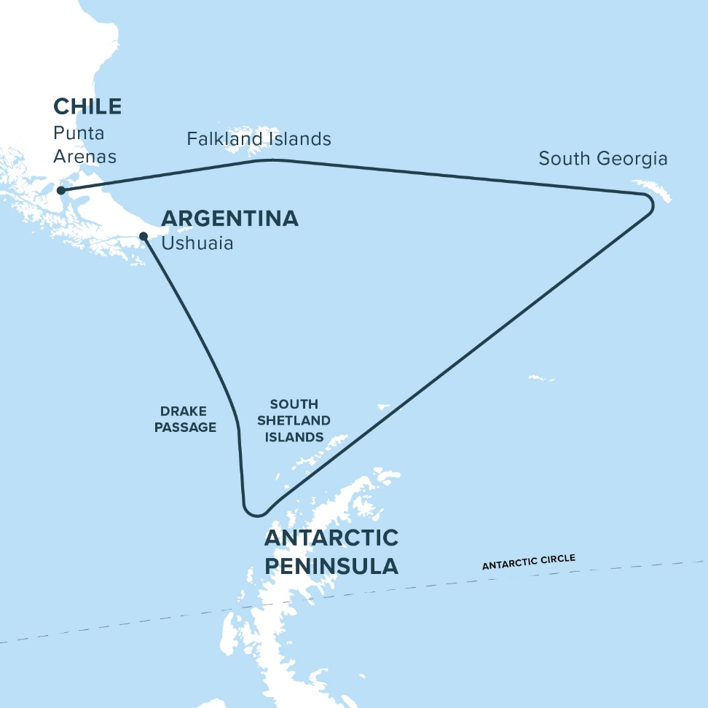

ITINERARY
Day 1: Punta Arenas, Chile
Day 2: Punta Arenas
Day 3: At Sea
Day 4–5: Falkland Islands
Day 6–7: At Sea
Day 8-10: South Georgia
Day 11–12: At Sea
Day 13–16: South Shetland Islands and Antarctic Peninsula
Day 17: At Sea — Drake Passage
Day 18: At Sea — Beagle Channel
Day 19: Ushuaia, Argentina

HIGHLIGHTS

Discover the unique culture and history of the Falkland Islands and South Georgia
Famed for their role in whaling and exploration history, the Falkland Islands and South Georgia—a British overseas territory—offer an intriguing cultural experience.
South Georgia served as a major hub for the Antarctic whaling industry in the early 20th century. Explore the remnants of abandoned whaling stations and pay tribute to the legendary Sir Ernest Shackleton at his grave.
Immerse yourself in the incredible wildlife of South Georgia, including millions of penguins and breeding birds, thousands of seals, and over fifty per cent of the world’s population of Southern elephant seals. As you wander the beaches, be captivated by the magnificent presence of king penguins.
If the wildlife alone isn't enough to take your breath away, the stunning backdrop of mountains, fjords, and glaciers will leave you speechless.

Experience the wildlife of the South Shetland Islands and the Antarctic Peninsula
Sailing towards Antarctica there is a fall in temperature as we cross the Antarctic Convergence. You’ll see seabirds, whales, and other species that are attracted by the nutrient-rich waters.
Enjoy opportunities to see albatross, several species of penguins, as well as elephant seals, whales, and dolphins!

Admire breathtaking scenery such as icebergs, glaciated mountains, and volcanoes
Geology, glaciology, volcanology: in Antarctica, the mighty forces of the Earth are everywhere in evidence!
Marvel at the variety and beauty of icebergs, glaciers, and rugged mountains—many formed by volcanic activity.

Enjoy regular Zodiac excursions and landings amid spectacular scenery
To set foot on the continent of Antarctica is a rare privilege only a few can claim. Via Zodiac you will be able to appreciate the Antarctic ice and landscape up close.
Photograph stunning vistas set above still, clear water and explore Antarctica’s fascinating and beautiful terrain on guided landings.

Learn about Antarctic history from expert guides
No moment is wasted aboard Exploris One. Learn about the fascinating history of exploration in Antarctic waters from expert expedition team members.
Take your pick from our extensive collection of carefully curated books that will help you dive deeper into everything you learn along the way!

ITINERARY
Please Note: You are advised not to book a flight out of Ushuaia before midday on disembarkation day, in case of delays caused by unfavourable weather conditions.

Day 1: Punta Arenas, Chile
The Adventure Begins
Set on the windswept shores of the Brunswick Peninsula, this historic port city was once a vital stop for ships navigating between the Atlantic and Pacific Oceans—long before the Panama Canal changed global trade routes in 1914.
Arrive in the afternoon and meet your expedition team and fellow travellers. Gather for a warm welcome and orientation, then enjoy a festive group dinner featuring regional flavours and a taste of what lies ahead.

Day 2: Punta Arenas
Embark on the Exploris One
Spend the morning exploring Punta Arenas at your leisure—wander its colourful streets, visit a local café, or take in views over the Strait of Magellan. In the late afternoon, you’ll transfer to the pier where the Exploris One awaits, moored at the foot of the city. Step aboard and meet the captain and crew who will guide you on this remarkable journey.
In the evening, we’ll set sail through the legendary, wildlife-rich waters of the Strait of Magellan, bound for the Falkland Islands. From the deck, keep watch for Magellanic penguins, rock cormorants, petrels, and black-browed albatross gliding overhead—as well as the occasional raucous sea lion colony bidding us farewell.

Day 3: At Sea
Learn On Board
As we sail toward the Falkland Islands, take this day at sea to settle into life aboard the Exploris One and get to know your expedition team. This is the perfect opportunity to explore the ship’s inviting spaces, enjoy the view from the outer decks, and connect with fellow travellers.
Join our team of expert naturalists and historians to gain fascinating insights into the region’s wildlife, geology, and human history. Learn about the first archipelago we'll visit on this voyage—the Falkland Islands, or Islas Malvinas, as they are known in Argentina—and what lies ahead.
Spend time on the bridge or out on deck with the team as they scout for seabirds and marine life—your first taste of the remarkable biodiversity of this region.

Day 4–5: Falkland Islands
Enjoy Hiking, Zodiac Cruising, and Kayaking
Have your camera and binoculars ready as we approach the ruggedly beautiful Falkland Islands—a remote archipelago known for its dramatic cliffs, sweeping grasslands, and extraordinary wildlife.
These islands are famed for their vibrant penguin colonies, including gentoo, rockhopper, and Magellanic penguins—offering a fascinating natural spectacle against a backdrop of wild ocean and wind-swept grass. We’ll explore a variety of landing sites by Zodiac and on foot, with opportunities to hike across open landscapes, paddle through quiet inlets by kayak, and enjoy shore excursions shaped by the weather and wildlife around us.
Look out for large populations of black-browed albatross, Peale’s and Commerson’s dolphins, orcas, and a myriad of bird species—including the Falklands’ flightless steamer duck, imperial shags, and Cobb’s wren.
We’ll also visit Port Stanley, the island's quaint and colourful capital, which has a distinctly British outpost feel. Learn more about the complex and sometimes controversial history of the Falklands and enjoy time to explore the town. Keep your eyes peeled for southern giant petrels, endemic Falkland steamer ducks, kelp and dolphin gulls, black-crowned night herons, red-backed hawks, peregrine falcons, and turkey vultures.

Day 6-7: At Sea
Discover Fascinating History and Search for Wildlife
Set sail on an eastward course across the Southern Ocean, bound for South Georgia—home to some of the richest wildlife spectacles on Earth. Over the next two days at sea, we’ll cover more than 1,500 kilometres (837 nautical miles), journeying through open seas rich with history, mystery, and marine life.
This oceanic interlude offers time to slow down, reflect, and connect. Join your expedition team for presentations on the region’s dramatic history, fascinating geology, and the remarkable marine life that may appear along the way. Keep your eyes on the horizon—these waters are home to albatross, petrels, and the occasional sighting of large cetaceans. If whales are spotted, head to the decks to witness their powerful presence firsthand!
Stories of early navigators come alive here—none more compelling than that of Ernest Shackleton, whose fateful expedition passed through these very waters. Like him, we now look toward South Georgia, and if the skies are clear, we may catch our first glimpse of its mountainous outline on the horizon.

Day 8-10: South Georgia
Marvel at Penguins, Peaks, and Polar History
South Georgia captivates every traveller who steps foot on its shores. Home to one of the greatest concentrations of wildlife on the planet, the island’s beaches are blanketed with hundreds of thousands of penguins as far as the eye can see.
We’ll spend three days exploring this stunningly beautiful island—one that teems with life and is steeped in history. South Georgia played a pivotal role in Sir Ernest Shackleton’s legendary Endurance expedition and was once the heart of the southern whaling industry. You may even have the opportunity to visit the explorer’s final resting place at Grytviken.
Known as the “Galápagos of the South,” South Georgia is home to over thirty million breeding birds, thousands of seals, introduced Norwegian reindeer, and nesting sites of wandering albatross. The island hosts four species of breeding penguins. Watching thousands of them gathered together—sleek, dignified, and dressed in nature’s finest tuxedos—is a sight you won’t soon forget.
Each day offers a new landing and a new perspective. Hike across plains where fur and elephant seals lounge between glacial streams. Marvel at snowy peaks, emerald bays, and electric-blue glacier ice. Visit abandoned whaling stations that speak to a complex past and observe a living world that thrives in one of the planet’s most remote corners.

Day 11-12: At Sea
Search for Seabirds and Icebergs
As we bid farewell to the wildlife haven of South Georgia, we set our course southwest across the Scotia Sea, bound for the South Shetland Islands and the Antarctic Peninsula. Here, the horizon stretches wide and empty, the silence broken only by the wind and the call of seabirds wheeling overhead.
Join the expedition team for engaging presentations on glaciology, Antarctic wildlife, and the icy ecosystems ahead. Outdoor viewing areas and time on the bridge offer excellent opportunities for spotting seabirds and scanning for icebergs as we cross into polar waters.
Beyond the sixtieth parallel, we may begin to encounter vast tabular icebergs—flat-topped giants calved from the Weddell Sea ice shelves—heralding our approach to Antarctica. As each day passes, we deepen our understanding of this frozen frontier, learning more about the wildlife and natural forces that shape it.
In between lectures and birdwatching, take time to unwind in the ship’s sauna or jacuzzi, connect with fellow travellers, and enjoy the many comforts aboard Exploris One.

Day 13-16: South Shetland Islands and Antarctic Peninsula
Step Foot on the Frozen Seventh Continent
Spend four unforgettable days exploring the South Shetland Islands and Antarctic Peninsula—a region that has captivated explorers for centuries and continues to enchant modern-day travellers.
Antarctica dazzles with its scale and silence. Towering peaks and electric-blue glaciers dominate the skyline, while chinstrap, gentoo, and Adélie penguins crowd the shores. Crabeater, Weddell, fur, and elephant seals sprawl across the ice, and seabirds trace lazy arcs overhead. Listen for the thunderous crack of a calving glacier or the raucous chatter of penguins fiercely defending their perfect nesting pebble.
We’ll make the most of every opportunity to explore—whether it’s hiking along ridgelines with sweeping views, kayaking through brash ice, snowshoeing over white terrain, or enjoying spontaneous Zodiac cruises that bring you close to Antarctica’s wonders. Between landings, our on board experts will continue to share insights through lectures, workshops, and informal conversations.
Sites like Brown Bluff, Paradise Bay, and Neko Harbour offer ever-changing possibilities for exploration—each shaped by the mood of the sea, the will of the weather, and the wonders that await. We may visit Deception Island, the flooded caldera of a collapsed volcano, where black-sand beaches contrast starkly with snow and steam, or sail through the Gerlache Strait, threading among towering bergs and glacial cliffs.
As we cruise from one site to the next, take in the scenery from the outer decks or enjoy the ship’s health and wellness amenities—from the spa and sauna to the fitness centre and a relaxing massage. And for the truly adventurous, there may even be a chance to take a polar plunge into the icy Antarctic waters!

Day 17: At Sea — Drake Passage
Indulge in Whale Watching and Iceberg Spotting
We set our course north across the legendary Drake Passage—the stretch of sea that separates Antarctica from South America. Named for explorer Sir Francis Drake, these waters are famously unpredictable—sometimes calm and still, other times wild and rolling.
Head out on deck to look for the mighty albatross that flies overhead, scan the waters for breaching whales and drifting icebergs, or enjoy the view from the warmth of the observation lounge.
As our journey winds down, the expedition team shares closing reflections on the Antarctic Treaty and its vital role in protecting this region. After two weeks of wonder, we return with a renewed sense of connection—and a shared commitment to protecting this extraordinary part of the planet.

Day 18: At Sea — Beagle Channel
Sail Past Fjords, Forests, and Wild Shores
Journey through the majestic Beagle Channel—a narrow, glacier-carved passageway that winds between the southern edges of Chile and Argentina. Framed by rugged mountains, windswept islands, and forests that spill down to the sea, this storied waterway—named after the ship that carried Charles Darwin—offers a peaceful stretch of sailing and a chance to reflect as seabirds wheel overhead and soft light plays across the water.
As we navigate past remote islets and rocky shores, watch for sea lions basking in the sun, imperial cormorants lining the cliffs, and dolphins weaving through the ship’s wake. With the Andes rising in every direction and the waters leading us gently toward Ushuaia, the Beagle Channel offers a serene and stirring finale.

Day 19: Ushuaia, Argentina
A Fond Farewell
Disembark in Ushuaia after enjoying your final breakfast on the Exploris One. You have an included transfer to Ushuaia airport if you're flying home today, otherwise, enjoy some extra time exploring Tierra del Fuego and its rugged surroundings.
A departure transfer to the airport is included in your voyage fare if you are flying out today. Please speak to your agent to organize this.
If you are flying out today, please do not book your flight to depart Ushuaia before midday in case of any delays caused by unfavourable weather conditions.

PRICING AND CABINS
Exploris One is the operator for this Antarctic expedition. This bilingual (English French) cruise offers a welcoming experience for all guests, with programming delivered in both languages throughout the journey. Join Adventure Canada's hosted group and embark on an unforgettable journey with Exploris One. Our collaborative efforts guarantee an engaging, informative, and enjoyable travel experience.

Cabin Category A $29,995
Cabin Category 9 $36,395
Cabin Category 8 $ 31,860
Cabin Category 7 $ 28,595
Cabin Category 6 $ 27,295
Cabin Category 5 $ 24,525
Cabin Category 4 $ 22,395
Cabin Category 3 $ 20,695
Cabin Category 2 $ 19,995
Cabin Category 1 $ 18,495

S
Details
Starts: Punta Arenas, Chile
Ends: Ushuaia, Argentina
Group size: 120 guests
Fitness Level: Moderate
Age Limitation: 8 and over
Cruise Payments: International Cruise fares are priced in US dollars and are per person, per Cruise. A $2,500 USD deposit per person, per cruise is required to register. Your final balance for the Cruise is due 120 days prior to the scheduled departure date (“Departure Date”). All late payments are subject to a penalty of 1.5% interest per month, or 18% per annum. Adventure Canada reserves the right to cancel your booking if it is not paid within 120 days of the Departure Date or deny boarding due to any unpaid balances, without a refund to you. Name changes are not permitted.
Cancellation by the Passenger: Adventure Canada receiving a written notice of cancellation at least 121 days prior to the Departure Date, you shall receive a refund of the amount paid for the Cruise, less an administrative penalty of $2,500 USD per person, per Cruise. If a written notice of cancellation is received by Adventure Canada between 91 and 120 days prior to the Departure Date, the cancellation penalty is 65% of your total cruise cost. A refund of 35% of the amount paid for the Cruise will be issued provided the passenger is up to date on all payments. In the event of a cancellation made 95 days or less before the scheduled date of departure, you will forfeit any amount paid for the Cruise to that date. For these and other reasons mentioned within these Terms and Conditions, you are strongly advised to obtain comprehensive cancellation insurance at the time of registration.
Travel Insurance: A minimum of Emergency Medical and Evacuation Insurance is mandatory for participation in all Adventure Canada Cruises. You must carry a minimum of $500,000 USD per person emergency medical and evacuation coverage.
Future Travel Credit: Future Travel Credits do not apply to and will not be issued for any cancellation reason by the passenger.

Inclusions and Exclusions
Included
- Full-board cruise from dinner on the first day to breakfast on the last day
- Welcome cocktails and Captain’s Gala Dinner
- Port taxes, disembarkation fees, and entry fees for protected areas (€50 per person per day)
- Open Bar package
- Room Service (menu available in the cabin)
- Zodiac landings, zodiac cruises, kayak, and other onboard activities
- Conferences, lectures, and briefings from a fully bilingual & highly qualified team of guides and naturalists
- Boots specially adapted for polar conditions and a polar parka are provided by Exploris. The inner jacket of the parka is offered to all passengers

Excluded
- International flights to Punta Arenas & from Ushuaia
- Cancellation, repatriation, baggage, and medical insurance (available on request)
- Personal expenses (dry cleaning, massage, hairdresser, boutique...)
- Crew gratuities at the traveler’s discretion (suggested at 12 €/night/person)
- Any other services not mentioned in the program

Registration Agreement
Please note that you are not considered booked until your registration agreement and deposit have been received by Adventure Canada.

Terms and Conditions
Please review our full Specialty Cruise Terms and Conditions for complete details on your booking with Adventure Canada. Do not hesitate to reach out if you have any questions or concerns. We are here to help.

